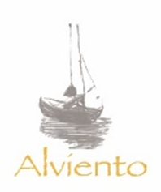
www.vinosalviento.com

CORTE BLANCO 2015
VALLE DE UCO, MENDOZA, ARGENTINA

Sailing into the wind our “living dream” is nestled at the base of the Andes Mountains. Each of our wines is single-batch and hand harvested from a single vineyard; we strive to deliver high end boutique wine to share with friends and family, producing only 300 Bottle yields of each very special blend;

This particular Alviento is a “Corte Blanco”, a Rhone style white wine that combines Marsanne, Rousanne and Viognier, with a slight touch of Sauvignon Blanc. This white has spent three months in neutral French oak giving it body and smoothness to work with a great variety of dishes.

This “Vino Suntuoso” is inviting and fresh; lemon blossom and ripe peach on the nose blends with fresh tangerine and a hint of burnt sugar on the palate. The bright acidity of this wine keeps the finish fresh and full.

